**Boston University**

**Electrical & Computer Engineering**

**EC463 Senior Design Project**

First Semester Report

Efficient Solar Hot Water

Submitted to

Professor Robert Kotiuga

8 St. Mary’s St Boston, MA

02215, Room 523

(617)-353-4151

prk@bu.edu

Team 21

Team Solar Panels

Team Members

Hal Levin [hlevin3@bu.edu](mailto:hlevin3@bu.edu)

Moises Bensadon [moises@bu.edu](mailto:moises@bu.edu)

Stanley Nguyen [stanguye@bu.edu](mailto:stanguye@bu.edu)

Submitted: December 11, 2022

#### Table of Contents

2

**Executive Summary** **3**

**1.0 Introduction** **5**

**2.0 Concept Development** **7**

**3.0 System Description** **8**

**4.0 First Semester Progress** **14**

**5.0 Technical Plan** **15**

**6.0 Budget Estimate** **16**

**7.0 Attachments** **17**

**7.1 Appendix 1 – Engineering Requirements** **17**

**7.2 Appendix 2 – Gantt Chart** **18**

**7.3 Appendix 3 – Other Appendices** **19**

# Executive Summary

Efficient Solar Hot Water

Team 21 – Team Water

As a team, we will be designing a smart, efficient, and low-maintenance solar panel hot water heating system. By adding a cooling process with water to existing solar panels, we can extend the cell’s life and efficiency. Our system would be built and implemented with residential household electrical and piping systems. A smart monitoring system will be designed in such a way that it would be flexible and sufficient for a majority of houses. This will be a heavy build project; requiring a mixture of electrical and plumbing skill sets to achieve a successful renewable energy system. The nature of the project will require modifications and/or changes to current or future designs in homes. Materials and processes such as choosing and purchasing solar panels will be necessary. For practical implementation, residential building assessments would be needed for optimal sun exposure and precise planning for solar hot water integrations.

The issue we are trying to tackle is the efficiency flaws of solar panels. In essence, we want to see what we can do to increase the efficiency of one of the greenest methods of capturing energy in order to accelerate its adoption. An important determining factor in photovoltaic efficiency is the temperature the solar panel is operating at. Generally, a lower photovoltaic temperature correlates to more efficient power production. Our technical approach to this problem is to create a monitoring system that can efficiently cool down solar panels in order to keep them at the optimal operating temperature.

Our design currently consists of a controlled water flow system with integrated heat pumps allowing for the transfer of hot and cold from photovoltaic to a hot water tank. Our design will feature automation, simplicity, and functionality that will produce qualitative results. Our final deliverables will show convincing results of efficiency increases while reducing costs of household energy consumption. A goal for this project is to be able to effectively and accurately model energy production against temperature. We will also plan on building a physical system that will be able to drive cooler water, or any heat-transferring medium, from a heat pump to reduce the temperature of the solar panels and heat up usable water that would be stored in a water tank. Throughout our design process, we will compare and model different cooling designs for this system and use data collected on energy usage and production from each variant of the system.

Some of the tech companies competing alongside us are Everything Solar®; RevoluSun®; and DualSun®. Among them, Everything Solar® and RevoluSun® are mainly selling solar water heaters. Traditional solar water heaters are not our main competing technology, but to some extent, we all use solar energy to heat water to reduce the energy waste of electric water heaters. SPRING®-Hybrid solar panel designed by DualSun® is very similar to our design philosophy. DualSun® is a European-based technology company whose main products are hybrid solar panels and solar water heaters like ours. However, DualSun®'s technology is out of reach for the Americas, where they have neither agents nor direct sales channels.

# Introduction

Our purpose in this project is to research and design a system to fulfill the needs of our client. Our client, Professor Kotiuga from Boston University, proposed a systematic improvement to current solar panel systems used in commercial and residential buildings. The inspiration behind Professor Kotigua’s idea is that solar panels can increase power production if they’re cooled down to an ideal temperature. Current solar panels are around 15%-22% efficient when operated under optimal conditions. At very hot temperatures, the efficiency and power output of the solar cells can decrease by a reasonable amount.

Our client has a vision for his project and is looking for a system that can increase the efficiency of photovoltaics without compromising too much energy. With basic laws of energy, we know that cooling such a system will come at an energy cost. The approach to our system will be to research a way of cooling the panels while having the increased efficiency be greater than the amount of energy needed to operate the system. Our client will be working with us in the design and manufacturing of a new solar panel system that would integrate water cooling into the system with the feature of being able to use heated water as per usual in current buildings.

Our goal is to increase solar panels' efficiency by using the cold water pumped out of water tanks or from a separate pipeline. A few crucial parts of the design we will have to look out for include pipe diameter, water pump flow rate, and materials that have a high heat transfer coefficient. Our team has already constructed a minimum viable product that allows cold water to flow through the solar panel while the solar power can absorb solar energy and charge a small car battery. So now we will be analyzing and tracking cell temperature vs. power production to determine what the ideal temperature for maximum power efficiency would be. The cold water will ideally come from the exit tube of the home’s water heater since this already exists in most homes and wouldn’t require additional power dedicated to cooling the water.

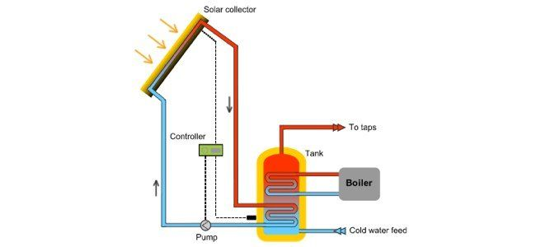

*Figure 1: A basic layout of how solar hot water systems work, our implementation would replace the solar connector with a photovoltaic*

With current climate change and rising temperatures, any improvement in the efficiency of energy generation is crucial and beneficial. Solar panels have been decreasing in price in the last couple of years but their efficiency hasn’t reached the levels of powering an entire home. Cooling solar panels can be a simple concept, but how can we do so in the most efficient way possible and create the least amount of waste? Something that is used regularly in typical households is water from pipelines. This water comes in cold from the outside. We will need to engineer a way of efficiently circulating water through the panels and eventually back to water heaters already present in a home.

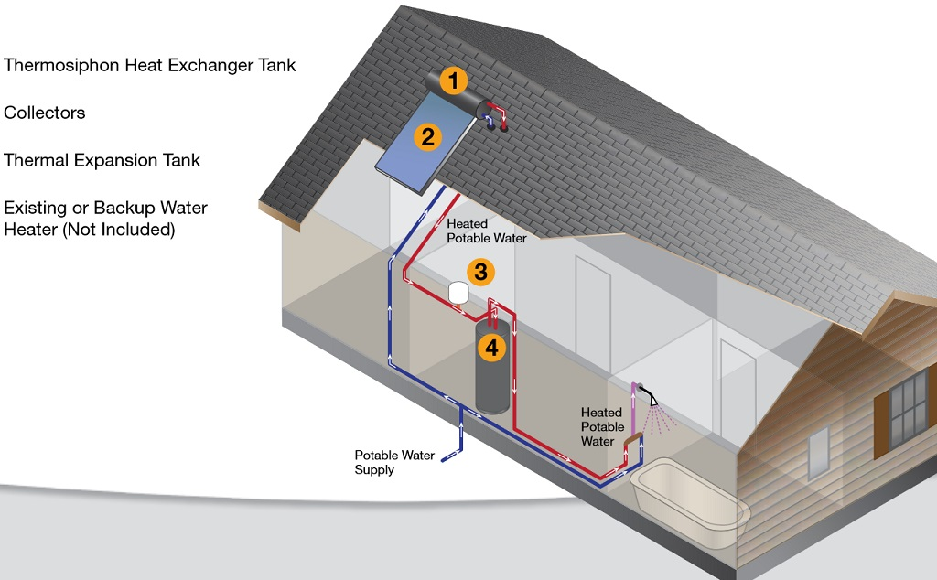

*Figure 2: How we envision our system to be implemented in an individual home setting. At point 1, water is stored and sensed. Once the system has decided it is time to circulate water, a pump between points 1 and 3 will be activated where warm water is moved into point 4, a water heater tank to be used in the future. Heated potable water will be heated with less energy with our system as warm water has been placed in the water heater from the solar panels.*

# Concept Development

All of this system also has to be designed in a way that is appealing to users, and therefore we plan on creating an intuitive user dashboard for customers to view power production on a given day and the estimated increase in efficiency due to the cooling system. A possible reach goal that we could go for is implementing a system that would decide if it is more efficient to use the extra power gained to (a) power the water heater, (b) store it in batteries for future use, or (c) sell the energy back to the city grid. The reason behind these choices would be based on the time of year, the fact that batteries lose charge over time, and the price the city pays for electricity buybacks. Because most comparable products would come with rather advanced dashboards we aim to make the management portal very sleek and useful to the consumer. Possible ideas include connecting to internet to add local weather predictions and maybe even integrating with smart home protocols if time permits.

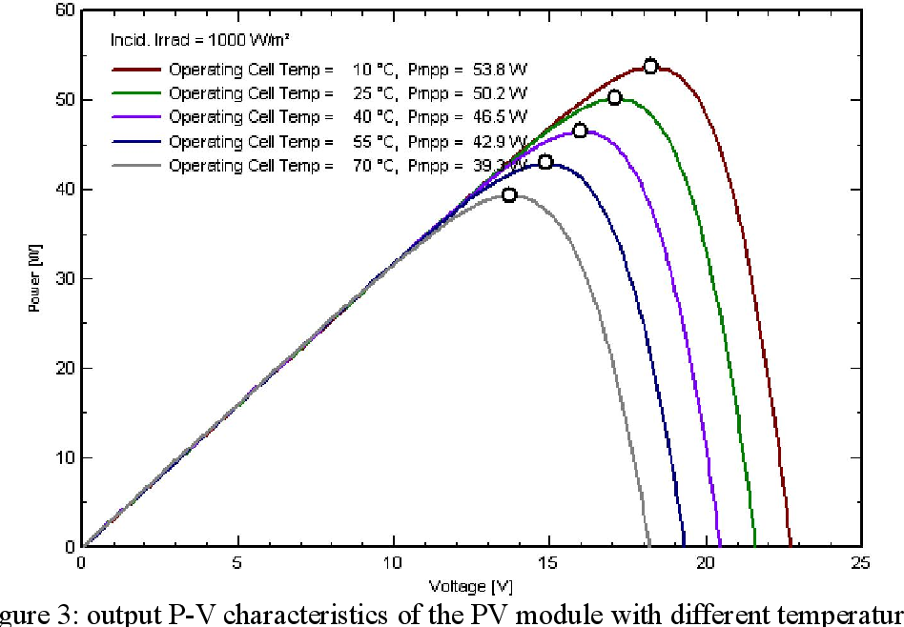

*Figure 3: Solar panels need to be at the right temperature to output maximum power for the same input.*

# System Description

We need to ensure that solar panels will no longer reach temperatures where efficiency will begin to drop and become less efficient. The extra heat generated by the solar panels will heat our cooling water, which will be used as domestic hot water, reducing the energy that would have been used to heat water that is much colder.

A sufficient water pump will also be required for adequate water flow and pressure that is needed to achieve the cooling that is needed. This pump ideally would be as efficient as it can be while having enough torque. A choice between DC vs AC motors and pump was evaluated and chosen accordingly.

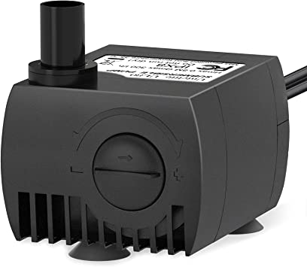

*Figure 4: Submersible 80 GPH 4W water pump for our design.*

For the time being, we went with an aquarium-rated water pump, capable of 80 gallons/hour. The max power of this pump is rated at 4 watts. While this low-power water pump is a good choice for this application in terms of power consumption, pump power might be limited and will be tested for our final design. This water pump is a traditional pump that uses an AC input at 120 or 240 VAC. During our prototype stage, we used a relay controlled by our microcontroller to switch on and off power from a 120 VAC outlet. We were also able to achieve this by splicing the hot wire from the water pump and adding a relay, acting as a switch.

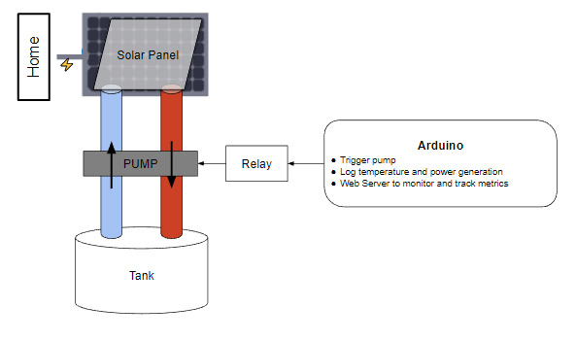

*Figure 5: Our prototype design of the solar hot water system with the water pump integrated into the system. This system for now will move hot and cold water between the solar panel.*

Temperature sensors will be used to ensure that we can monitor the temperature of the solar panels and water and let the system make automatic adjustments. We created a monitoring system that is able to record the temperature of solar panels and the water that it carries through a small thermistor. This device is part of the semiconductor family where it is able to act as a resistor that is sensitive to temperature, similar to the photovoltaics in our solar panels. Here, the measured value of a thermistor’s electrical resistance is directly correlated to the temperature of the environment in which the thermistor is put in; this will mainly be hot or cold water temperatures.

From our Arduino, we can use its analog input to read the resistance of the thermistor to determine the temperature of the panel. Once we have a base case of resistance and its corresponding temperature, we can extrapolate that to determine if the solar panel temperature is too hot or not. Once the Arduino reads a resistance value that indicates a high temperature of the water, this information will be fed to the microcontroller where we can send a digital output of 5V to the relay signal pin to activate the switch.

The water pump will move cold water through the panel once this switch is activated. Enough water must be moved so that new, colder water is able to take place and effectively cool down the panel. If we move too much water, we are wasting extra energy by doing so, reducing the efficiency of the system. There will be a cold water source or water tank near the solar panel to ensure that we have enough cold water to cool the solar panel in case the cooling water is overheated, the solar panel's heat dissipation efficiency is low, and the energy conversion efficiency is reduced. We will measure how long it will take to fully circle one cycle of water through flow rate calculations and testing once we design our final product.

After the cooling water has absorbed enough heat from the solar panels, it will be transported to a warm water tank, where it may be heated by a heat pump used to cool the cooling water and piped to household use hot water. The heat pump will be powered by the electricity generated by the solar panels, which will trade for a higher energy conversion ratio than an electric water heater at a lower cost.

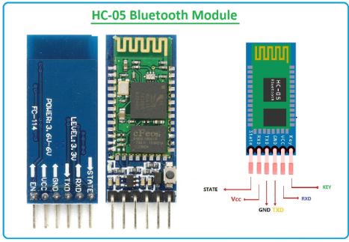

*Figure 6: The HC-05 Bluetooth module we plan on implementing for our system.*

During our time designing our system, we wanted to find a way to configure our wireless communication systems. The first concept we decided to design was Bluetooth technology for the Arduino. For this, we would have to purchase an Arduino with Bluetooth integrated into it, or we could get external modules that use Arduino as the primary processor. This Bluetooth idea can also be used to monitor the system via a smartphone. Information about the system such as current, voltage, temperature, and motor statistics will be given to the user. A possible module for this application would be the HC-05 Bluetooth module for the Arduino. This Bluetooth module will be used mainly as a way of connecting the phone to the primary Arduino board. The primary will be the main receiver and send information out to the secondary receiver which can take feedback from temperature sensors that would be placed on the solar panels and in the water system. The module has an operating voltage of 3.6V - 6V with a max threshold of 7V. This should be sufficient considering the Arduino operates on a lower voltage level. From the manufacturer’s documentation, the parameters are sufficient for our purposes. The PCB dimensions are 37.3mm (long) x 15.5mm (wide) with a board weight of 3.5g. This lightweight and small-sized module will be good with integration within our system.

The signal pins are EN/VCC/GND/RXD/TXD/STATE (Bluetooth state leads, not connected output low level, the output high level after connection). With the connection status indicator, the LED flash indicates no Bluetooth connection; the Led slow flash indicates enter at command mode. In command mode, the Bluetooth is ready to receive control from our system. The benefits of this board are that it carries an On-board 3.3V voltage regulator chip, input voltage DC 3.6V-6V; When not paired, a current of about 30mA is pulled (due to LED lights flashing, current in the state of change); After the pairing succeeds, the current is about 10mA. This low-power operation is perfect for our system where efficiency and power consumption are key factors of our design success.

This module will also have an effective transmission distance of 10 meters in an open area, more than 10 meters is possible, but will not ensure the quality of the connection. Lastly, the module has a default baud rate of 9600, giving it the capability of sending 9600 bits per second. This module will ensure a strong and reliable connection for the user to the hot water system.

With the module being able to communicate with the smartphone, we have decided to add a communication method for the two Arduinos we would use so they can send information to each other. For this function, we did research and found the nRF24L01 wireless communication module. It uses the 2.4 GHz band and can operate with baud rates from 250 kbps up to 2 Mbps, with a shorter range of course. With a power consumption of 12mA, this is perfect for our system which relies on energy efficiency.

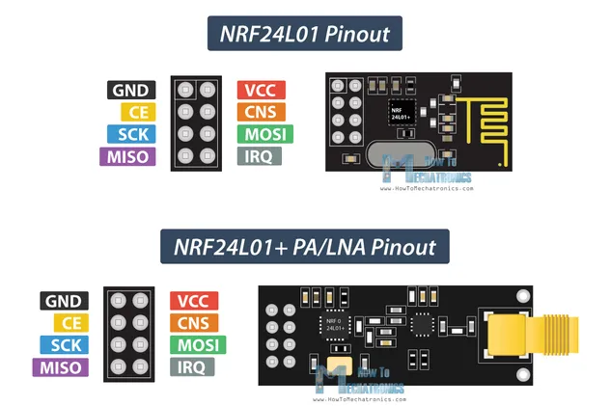

*Figure 7: A closer look at the input and output of the antenna module. The module on the bottom features an external antenna extension that could net us 1 km of range.*

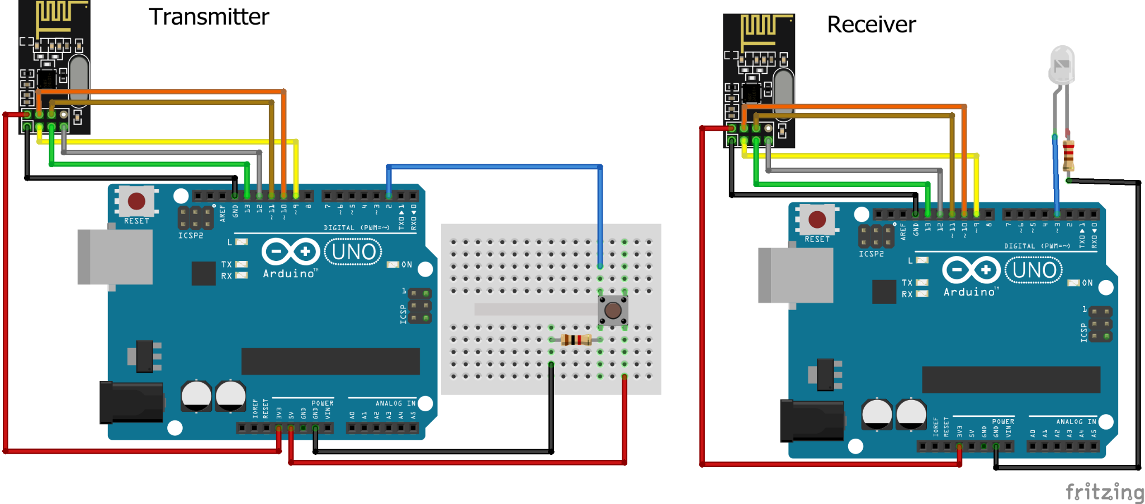

*Figure 8: Our test configuration for wireless communication between two Arduinos*

This is a model of how our wireless system will work once we add more features. It will build on this simple button transmission where a receiver will take that input and output a LED to show that it had received the command. The primary system will be the receiver in this case. The receiver will mainly control the water pump that would be closer to the water tank near the bottom of a household. The secondary transmitter Arduino will sense the temperature of the water and solar panel with and thermistor. As explained earlier, that input read of resistance will be processed locally in the secondary and will send a logical true or false to the primary receiver. The receiver will read this information and trigger the relay to switch on or off according to the transmitter. The successful connection of these two arduinos will allow for accurate and reliable communication and control of the water system.

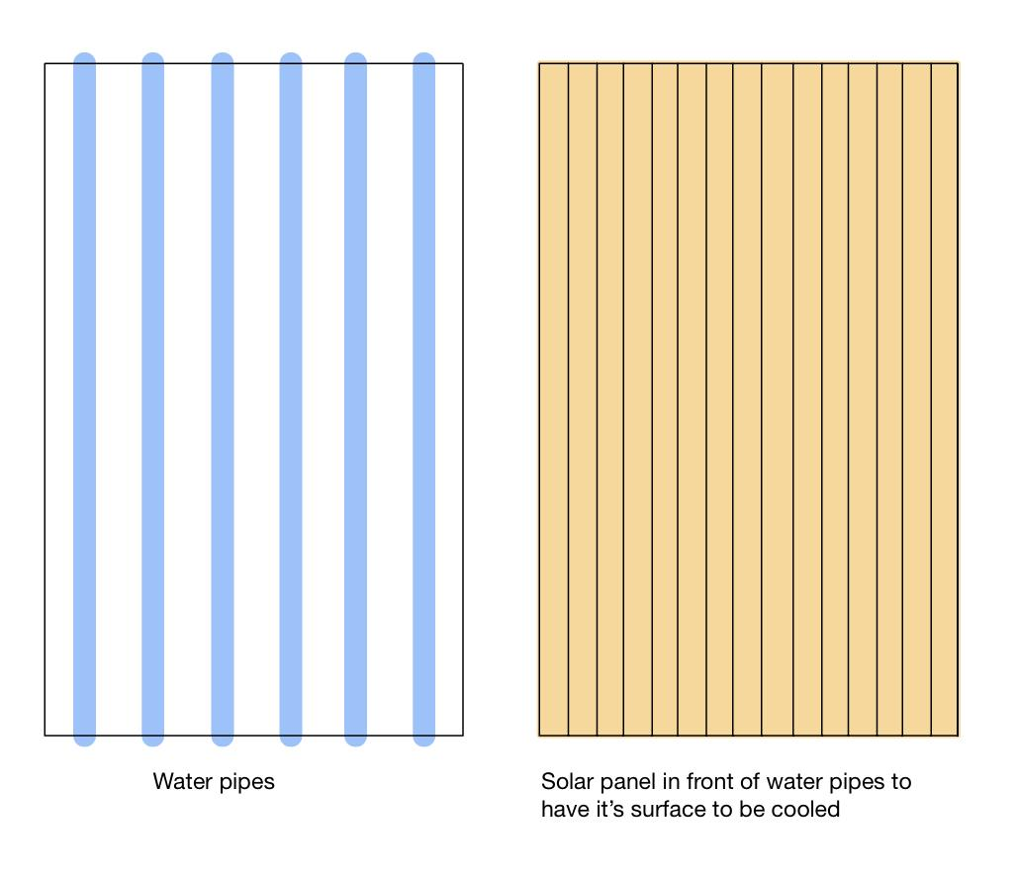

*Figure 9: Schematic diagram of the separated cooling/warming panel and solar panels*

# First Semester Progress

So far, we have successfully built our minimum viable product which we intend on using for testing. Below are two images of our current setup showing the water tank filled with ice water and plastic tubing distributed behind the solar panel. All of this is currently mounted on a wooden frame that can be easily transported or repositioned.

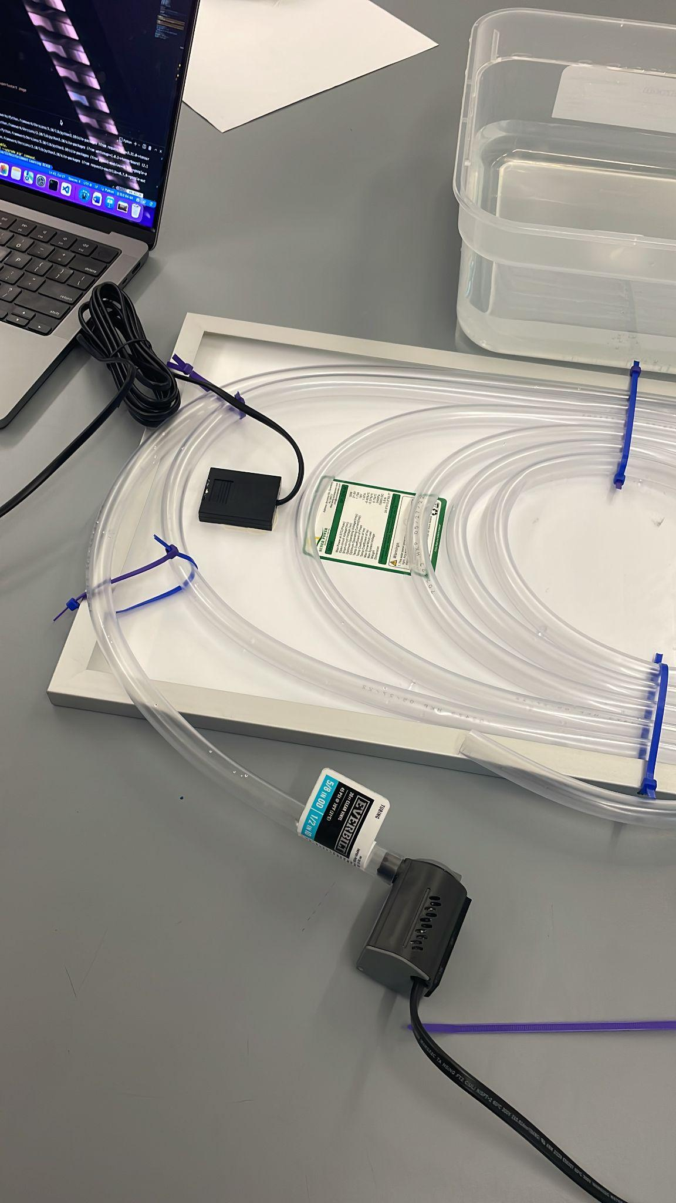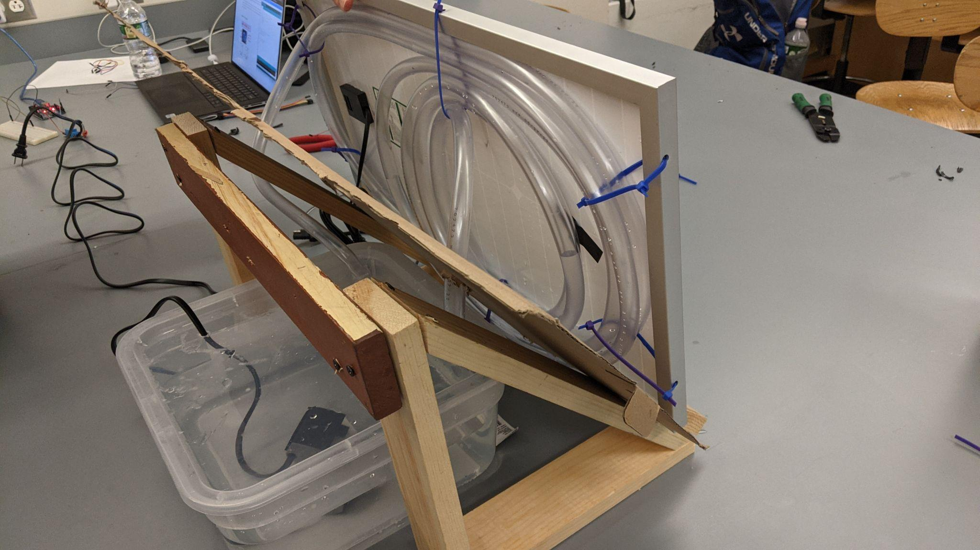

*Figure 10: Showing current distribution of plastic piping under Figure 11: Solar panel laying on the wooden mount with water storage solar panel*

# Technical Plan

During the second semester we plan on building on top of our original design and using finalized materials. The whole purpose of our first design was to create a prototype that would allow us to gather data. Our goal with our second design is to build a more robust system that includes a monitoring system that can track different KPIs of our product.

*Task 1. Materials*

*We plan on replacing the plastic tubing with a more conductive material, possibly copper. This would imply a redesign of the distribution of the tubes and we would want to be as cost effective as possible. Lead: Hal Levin*

*Task 2. Lab Environment / Testing*

*We are going to need to run our system through some testing in order to determine the optimal temperature. Lead: Stanley Nguyen*

*Task 3. Dashboard*

*Currently, we plan on having a local web page that will display important metrics relating to the solar panel and its power consumption. Lead: Moises Bensadon*

*Task 4. Wireless Communication*

*If we decide to install two separate control modules (i.e. one arduino on the roof and another below) we will need them to communicate and will most likely use bluetooth. Regardless, we can still use bluetooth in setup to get the system set up or to tweak parameters. Lead: Stanley Nguyen*

***(No more than 4 pages.)***

# Budget Estimate

| **Item** | **Description** | **Cost** |
| --- | --- | --- |
| 1 | 12V Car Battery (From Team Member) | $0 |
| 2 | Wood (Supplied by BU Theater) | $0 |
| 3 | Arduinos (Supplied by lab) | $0 |
| 4 | Power Inverter | $9 |
| 5 | Solar Panel (From Team Member) | $0 |
| 6 | Tubing (Vary by length and diameter) | $20-40 |
| 7 | Water Pump | $20 |
| 8 | Water Storage | $10 |
| 9 | Bluetooth module | $5 |
| 10 | NRF24L01 Antennas | $2 |
|  | Total Cost | $66-86 |

For our budget estimates, we do expect most of our costs to occur during the building phase of our project. We expect many of our existing parts to be reused for our final design. This includes the 12V car battery, power inverter, solar panel and Arduino. Water tubing is currently plastic but we will transition over to copper or aluminum tubing for better thermal heat transfer characteristics. The price of these can vary by vendor and length. Our current estimates are higher than what we need to accommodate for errors in our design. The extra budgeting for the tubing was decided as we expect that to be a major difficulty in our design. Flexibility in this material will help us experiment and work on our design more freely. For our structure, we plan on using wood because a team member has access to a generous supply of wood and woodworking supplies for free. Much of our budget will be allocated to upgrading and purchasing extra supplies for our system.

# Attachments

# Appendix 1 – Engineering Requirements

Team #21 Team Name: Efficient Solar Hot Water

Project Name: Efficient Solar Hot Water

| **Requirements** | **Value, range, tolerance, units** |
| --- | --- |
| Mount dimensions | 4 ft x 3 ft x 3 ft |
| Power | 12V DC source with 120/240 VAC power inverter |
| Water Pump | 80 Gallons/hour |
| Water Tubing | Able to cool solar panel at least 5ºC |
| Dashboard | Display monetary savings, Power Usage, Amount of time spent cooling panel |

# Appendix 2 – Gantt Chart

| **Description** | **10/1/22** | **10/10/22** | **10/20/22** | **11/1/22** | **11/10/22** | **11/20/22** | **12/1/22** | **12/10/22** | **+++** |
| --- | --- | --- | --- | --- | --- | --- | --- | --- | --- |
| Research efficiency gains and preliminary designs |  |  |  |  |  |  |  |  |  |
| Determine solar panel + tubing choice |  |  |  |  |  |  |  |  |  |
| Temperature Trigger |  |  |  |  |  |  |  |  |  |
| Build mount |  |  |  |  |  |  |  |  |  |
| Water Pump + Relay |  |  |  |  |  |  |  |  |  |
| Log temperatures, current & voltage |  |  |  |  |  |  |  |  |  |
| Bluetooth interaction |  |  |  |  |  |  |  |  |  |
| Web Dashboard |  |  |  |  |  |  |  |  |  |
| Electricity grid pricing |  |  |  |  |  |  |  |  |  |
| Hot water routing |  |  |  |  |  |  |  |  |  |

# Appendix 3 – Other Appendices

“SPRING-Hybrid by DualSun Introduction” <https://dualsun.com/en/product/hybrid-panel-spring/>

“Everything Solar”: <https://www.everythingsolarsolutions.com/>

“RevoluSun”: <https://www.revolusun.com/>

Fesharaki, Vahid Jafari et al. “The Effect of Temperature on Photovoltaic Cell Efficiency.” (2011).<https://www.semanticscholar.org/paper/The-Effect-of-Temperature-on-Photovoltaic-Cell-Fesharaki-Dehghani/4eb139ee8e2cc5d722b14ced834f35a8183b1188>

“Is Solar Power Worth the Investment?” *Empire Renewable Energy, LLC | Subsidiary of EMPIRE SOUTHWEST, LLC*, Empire CAT, <http://solarbyempire.com/why-solar/solar-panel-efficiency#:~:text=Efficiency%20of%20Solar%20Panels&text=Today%2C%20most%20solar%20panels%20provide,being%20converted%20into%20useable%20electricity>.

“Solar Efficiency Measurement Using Arduino” <https://www.irjet.net/archives/V7/i5/IRJET-V7I568.pdf>